SULEYMAN DEMIREL UNIVERSITY

**ENGINEERING FACULTY**

**CSS 305 - Database Management Systems 2**

# Project documentation

**Checked by: Assem Talasbek**

**Made by: Rakhmetulla Damir**

### 

### Kaskelen, 2022

**Structure:**

* Abstract
* Introduction
* Aim and objectives of research
* Background Review
* Methods and Materials
* Data and Results
* Discussion
* Conclusion
* References
* ***Abstract***

The idea is to give users the opportunity to save their time. Help people find all the information they need about sport playgrounds on our site, and book in advance at a convenient time for them.

Because, according to our research, there are no such sites, namely with the possibility of pre-booking. It's also convenient for landlords too. After all, users will not have to browse social networks looking for sport playgrounds to rent, and landlords will not have to answer the same questions every time, and our project will also help reduce human errors.

* ***Introduction***

The goal of the project is to help people quickly and easily find sports facilities by booking them in advance. Since the study did not find sites that could provide such a service to users. Although there were quite a lot of such sites abroad. Our project would help not only users but also landlords to save time.

Especially now the sport is developing very well. Day after day, more and more people are interested in sports. After all, it all starts with a joint trip to tennis / volleyball / basketball, etc. with friends, classmates or colleagues to relax and just have fun, have fun and spend time usefully.

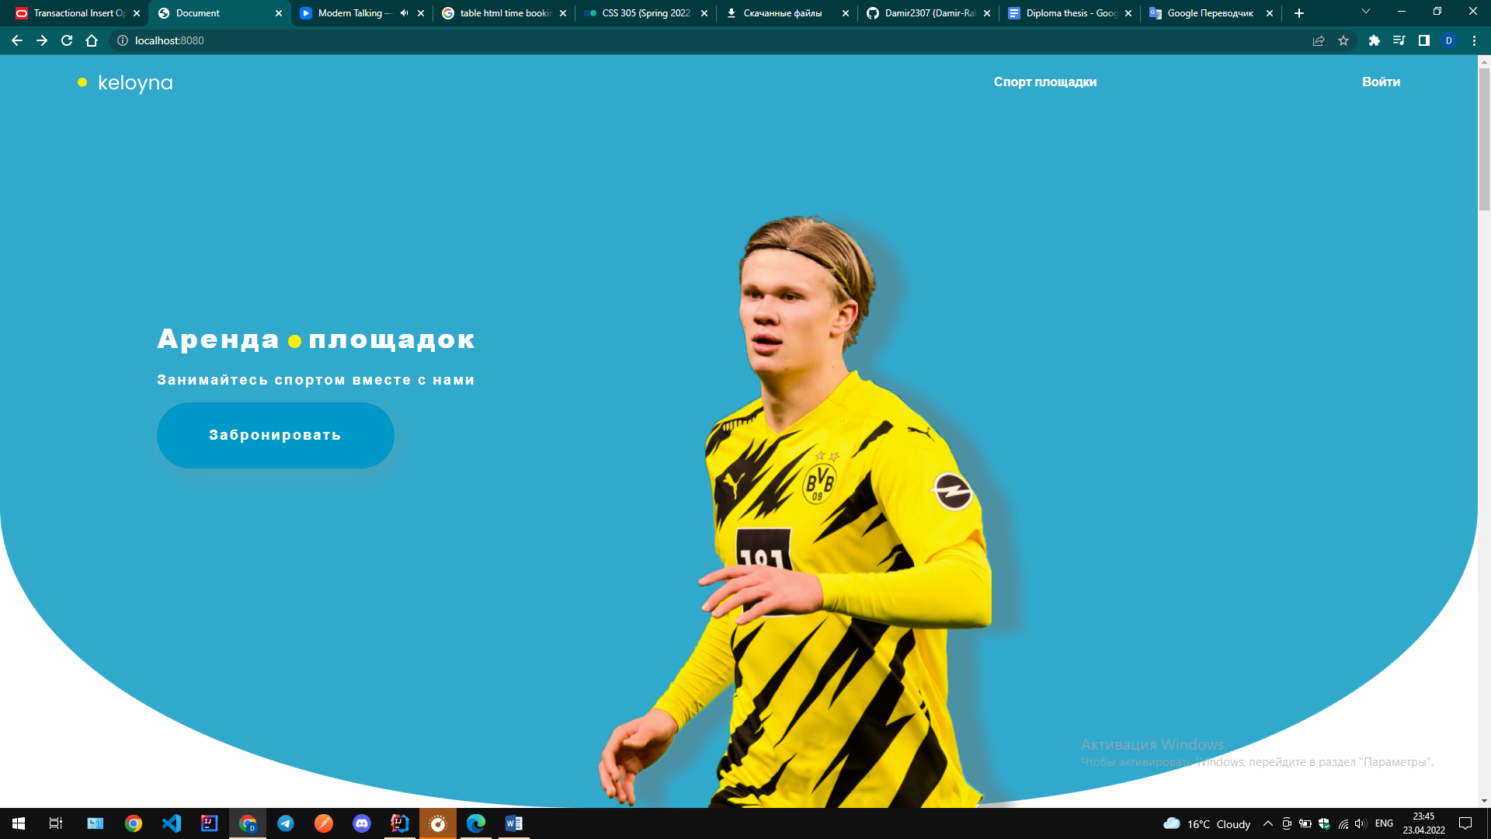

Figure 1. Cover of our product

* ***Aim and objectives of research***

***Aim:*** To develop a web site where the user can go and find any sports ground. See the site description, reviews, and if you like, choose a convenient time and date to book the hall in advance.

***Objectives:***

Collect all playgrounds data from Almaty

Collect data about specifications of playgrounds

Classify sports into separate sections for easy selection of playgrounds

Develop a platform on which the user can find any type of playground

Write some filters for playgrounds

* ***Background review***

Market research:

1. The site is larenda.kz[1], where you can book anything. The site is quite old, there are a lot of things. The design does not meet current standards and design rules. For users to find here, what they need will be very difficult. But here you can find a section for renting sports grounds. The downside is that the site does not indicate how to quickly and easily book it. That is, numbers are indicated where you will need to call, specify the time, etc. Thus, this site only solved one user need by collecting all the sites in one place. But it did not help to book it quickly and easily.

2. Website cenotavr.kz[2], where you can place an ad like on krisha.kz. It also has a very inconvenient and outdated design. It is not possible to make a reservation, users can only view the location and price of the sports ground.

3. The site sportmap.kz[3], if compared with the above sites, we can say here is a nice and more user-friendly design. But the reservation problem was not solved here either, and they simply indicated the contact details of the landlords.

4. Site mos.ru[4], is a Russian site where all sports grounds are collected and it is also possible to book by specifying the time and date. For users, the design is not too complicated, but when trying to book with UX, the part is a little incomprehensible. In general, the site solved the problem of reservation.

5. Site speedrent.ru[5], a Russian site, the design is quite understandable for users, plus from the above sites, in that they wrote in detail about the sports ground: what is available, what is not available, reservation recording, hall preview recording.

* ***Methods and Materials***

***Collect data and connect:***

To collect data about sport playgrounds in Almaty, I manually looked at all websites via the Internet and saved to excel file. There were some moments when it was necessary to write to the playground’s Instagram to collect more data about the site. Through Excel and Spring framework, I added everything to the Oracle database.

* ***Data and Results***

Presently, for all the time I spent on data collection we collected 45 playgrounds(+45 specifications) from the websites like larenda.kz[1], sportmap.kz[3], sportclubs.kz[6] and via Instagram.

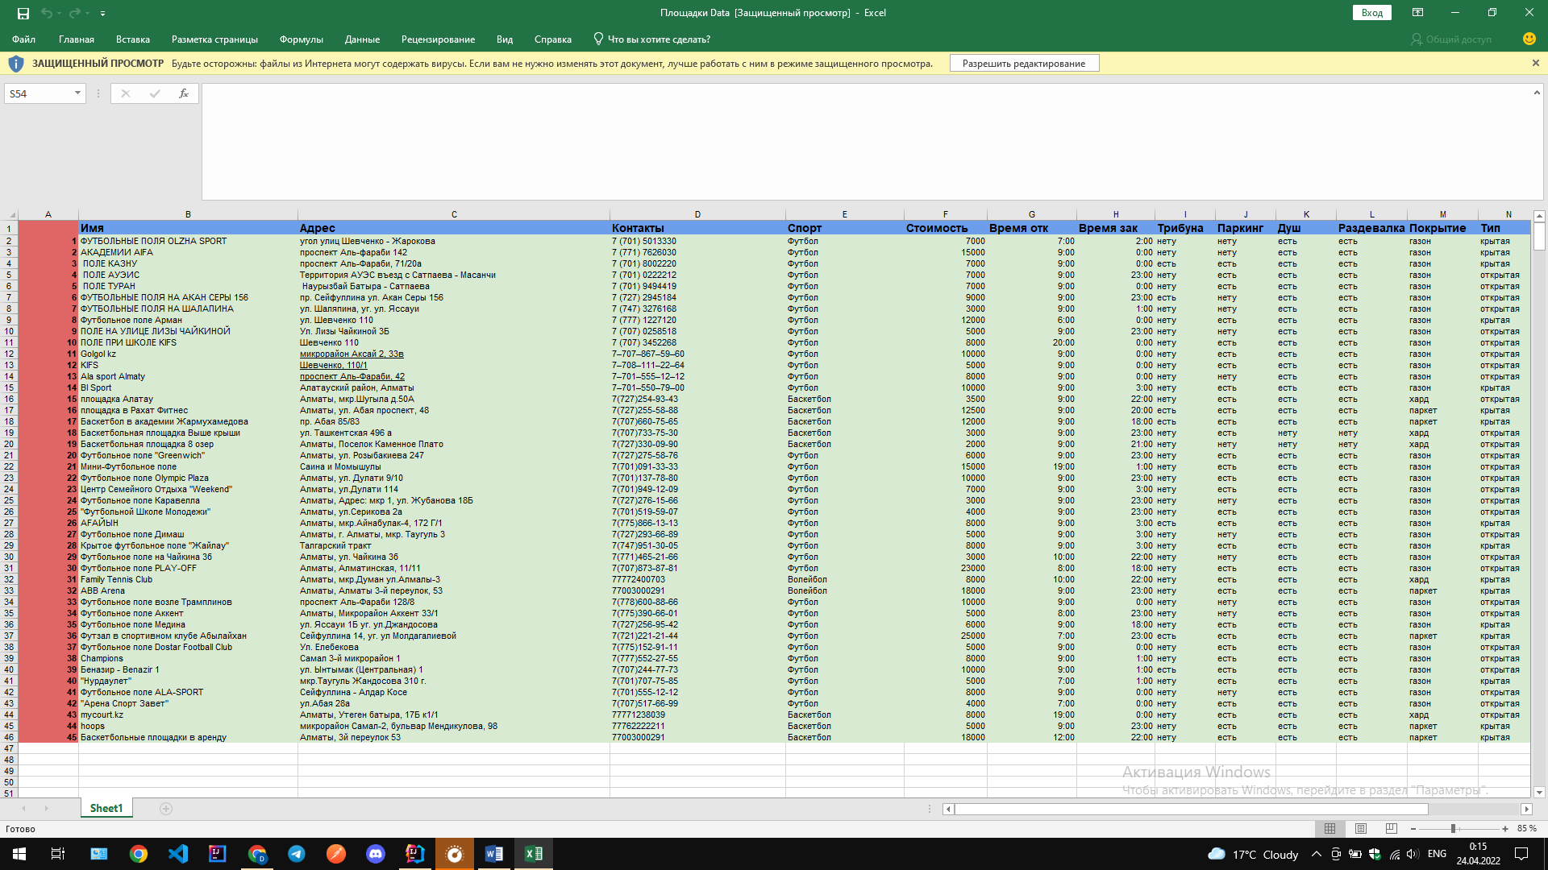

Figure 2. Playgrounds and their specification table

***Data about playgrounds:***

id - a unique identifier of the profession

playground_name – the name of playground

playground_address – the address of playground

price – price of playground for 1 hour

startime – time when the playground opens

closetime – time when the playground closes

phone – phone number of playground

sport – type of sport

photo – photo of playground

***Data about specification of playground:***

Cover – cover of playground ex:(газон,паркет)

Roof type – roof type of playground ex:(крытая,открытая)

Shower - is there a shower in this playground?

Dressing room - is there a dressing room in this playground?

Parking - is there a parking in this playground?

Tribune - is there a tribune in this playground?

Width – width of playground

Height – height of playground

***Data about type sport:***

Sport name – name of sport

* ***Discussion***

The project is also planned to be expanded, adding not only the rental of sports grounds, but also additional circles for beginners. Create one community of like-minded people by adding chat and the ability to challenge each other.

* ***Conclusion***

As a conclusion, I would like to say that for sports fans who want to spend the weekend with friends, colleagues, family, having fun, and most importantly with health benefits, our project will be an excellent option, which will help them not to sit and search on Instagram, Google for all the sports grounds, but go straight to our site and thus save time in a fast and convenient way.

* ***References***

[1] https://larenda.kz/almaty/sportivnyje-ploshhadki-i-zaly/

[2] http://cenotavr.kz/

[3] http://sportmap.kz/

[4] https://mos.ru/

[5] <https://www.speedrent.ru/>

[6] http://sportclubs.kz/